CRITICAL DESIGN REVIEW TO THE NASA 2011 UNIVERSITY STUDENT LAUNCH INITIATIVE

A Study of Atmospheric Properties as a Function of Altitude

By
HARDING FLYING BISON
2011 USLI ROCKET TEAM

JANUARY 24, 2011

Table of Contents

1. Summary of CDR Report ---------------------------------------------------------- 2
a. Team Summary 2
b. Launch Vehicle Summary 2
c. Payload Summary 2
- Changes made since PDR -------------------------------------------------------- 3
a. Vehicle Changes 3
b. Payload Changes 3
c. Other Changes 3
- Vehicle Criteria -------------------------------------------------------------------- 4
a. Design and Verification of Launch Vehicle 4
b. Recovery Subsystem 10
c. Mission Performance Predictions 12
d. Payload Integration 14
e. Launch Concerns and Operation Procedures 17
f. Safety and Environment (Vehicle) 19
- Payload Criteria ------------------------------------------------------------------- 21
a. Testing and Design of Payload Experiment 21
b. Payload Concept Features and Definition 23
c. Science Value 24
d. Safety and Environment (Payload) 25
5. Activity Plan --------------------------------------------------------------------------- 27
a. Budget Plan 27
b. Educational Engagement 28
- Conclusion ----------------------------------------------------------------------------- 28
7. Appendix ------------------------------------------------------------------------------ 29
a. Camera Wiring Diagrams 29
b. Motor Preparation 29

- Summary of CDR Report
1.a Team summary
We are the Harding University Flying Bison Rocket team. The University is located at 915 East Market Street, Searcy, Arkansas. Our mentor and team official is Dr. Edmond Wilson.
1.b Launch Vehicle Summary
1.b.1 Vehicle size
This year we will be flying a six inch diameter rocket. The rocket will be 110 inches in length, and 643 ounces. We chose a larger rocket to incorporate our payload which is significantly larger than last year. We will use a pre-glassed phenolic airframe. The added weight will be offset by a more powerful motor. We will use an aft section that is 42 inches in length, a drogue section that is 15 inches in length, and a main section that is 28 inches in length.
1.b.2 Motor selection
We have selected to use the 75mm L-1222 hybrid motor from Contrail Rocket. We chose to fly a hybrid motor because they are safe to handle and because the University conducts research on hybrid motor emissions. The L-1222 has a length of 52.75 inches and a weight of 175.982 ounces. It burns for 3.1 seconds with a total impulse of 3693.88 Newton-seconds. The maximum thrust is 2689 Newtons.
1.b.3 Recovery system
We will deploy a 44” SkyAngle drogue parachute at apogee. We will deploy the 120” conical parachute from Public Missiles main chute at 800 feet. The rocket will descend approximately 66 ft/s and 20 ft/s under drogue and main respectively. We will use two PerfectFlight mini Altimeters to deploy the parachutes. We will separate our payload from the nosecone at 2500 feet using the Co-Pilot Version 2.0 Altimeter. After the rocket has landed, we will use the Walston retrieval system to track its position.
1.b.4 Rail Size
The launch rail extends seven feet up and can be rotated to fire at many angles from the horizon. The rail is 1 square inch with a .25 inch slot.
1.c Payload Summary

We are integrating the payload suggested by the Science Mission Directorate. We will take data for the temperature, humidity, pressure, solar irradiance, and ultraviolet radiation during descent and after landing. We will also take three pictures during descent and three pictures after the payload has landed. We intend to separate the payload from the airframe at 2,500 feet. The payload will also have a GPS system and a separate altimeter.

- Changes Made Since PDR
2.a Vehicle Changes

Since the PDR, we have modified a few sections of the airframe. The overall length has dropped from 121 inches to 110 inches. The main section was decreased by 8 inches, the drogue section was decreased by 1 in, and the end of the motor was brought 2 inches farther into the rocket body.

We have changed to the C-07 fin by public missile. We also placed a second centering ring at the aft of the rocket for added stability for our motor retainer. Also, the overall weight of the rocket has increased by 23 ounces. We originally planned to use a motor retention system that was integrated into a tail cone, but we have decided to use a basic circular motor retainer that will be screwed on and fastened to the aft centering rings. We have also added two pounds of mass to the aft section of the rocket to create marginal stability and keep the rocket under 5,300 feet. A small hole was added to the side of the airframe near the nosecone so that the payload will be able to use the sensors that demand outside light during its time inside the airframe.
2.b Payload Changes

Although the function of our payload remains the same as our original design in the PDR, we have made a few significant changes to the structure and hardware. We have decided upon a new microcontroller to handle the data collection from our sensors. We originally included accelerometers in our payload but we have decided that these sensors are not imperative.

We have also made final decisions on our structure. We have now decided on using a 3-D prototyper to build legs that will be spring loaded to the base of the structure. We have decided to use ⅛” T-6061 Aluminum as the base of our payload. We have changed the placement in the nosecone so that the base plate is placed at the beginning of the shoulder. We have switched from a single static rod to four rods placed around the edge of the payload to hold the payload in place inside the airframe and arrest the parachute after landing. We did not originally plan for GPS capabilities on our payload, but have become aware that this is a requirement, and have added an EagleTree system to the top deck of our payload. Also, we have removed the hanging camera system and placed the camera flat on the payload baseplate. We have added the altimeter from Public Missiles to replace our original choice which did not have the capability to deploy at 2500 feet.
2.c Other Changes
The most significant change to our budget was the cost of our motor. We originally planned to spend $1,500, but we have recently discovered that the cost is less than $700. We currently do not have any changes to our activity plan. We are staying with the plans we set for the PDR.
- Vehicle Criteria
3.a Design and Verification of Launch Vehicle
3.a.1 Mission statement, requirements, and mission success criteria
Mission Statement:
Our mission is to design, build, test, and fly a high powered hybrid rocket that will reach an altitude of exactly 1.00 mile and carry a deployable science payload that will take data for studying the atmosphere during descent and after landing. The measurements will include temperature, pressure, relative humidity, solar irradiance and ultraviolet radiation. Another part of our mission is to capture images during descent and after landing. This mission will be done safely with no injuries, no damage to property, and the entire rocket vehicle will be recovered without receiving any damage that would prevent it from further use.
Requirements:
In order to meet these mission goals, the following systems and plans must be procured or produced:
- Hybrid rocket motor using nitrous oxide oxidizer and hydroxyterminated polybutadiene with a 3694 Newton-second total impulse
- Nitrous oxide oxidizer supply tank that can deliver 10 liters of liquid nitrous with pressure regulator, fill and dump valves, temperature control to keep pressure between 600 and 900 psi
- Remote battery operated ignition system with 500 feet of cable that can control the fill and dump lines of the nitrous oxidizer supply and set off the electric matches which ignite Pyrodex pellets initiating the hybrid rocket flight
- On-board flight computer with backup computer capable of monitoring and recording apogee altitude and having pre-programmed capability to set off ejection charges to deploy a drogue parachute at apogee and a main parachute at 800 feet. Computers should have separate power supplies and manual switches to turn them on just before flight.
- Drogue and Main parachutes: drogue to deploy at apogee with main to deploy at 800 ft. Parachutes attached to airframe securely with ample shock cord to prevent breaking of shock cord and minimizing collision and entanglement of separated airframe parts
- Airframe that is 6 in. in diameter and that can withstand flight stresses and landing damage while also carrying the science payload, motor, recovery parachutes, flight recorder safely through the planned trajectory
- Fins that help maintain smooth and stable flight pattern with minimum turbulence
- Science payload with separate power supply to record temperature, pressure, relative humidity, solar irradiance, ultraviolet radiation, and capture images. An embedded controller will be required to activate the sensors, record and store their signals and provide interface to retrieve data at the end of the flight
- Portable Launch Stand for holding, aiming and releasing rocket for flight
- Scale drawings of all components, systems and subsystems to be assembled into the final competition rocket including launch stand and fixtures used to construct sub-assemblies
- Inventory Manual of all items needed for successful and safe flight of competition rocket at USLI launch site
- Procedures Manual for preparation of the rocket for flight
- Safety Manual for safety procedures, safety information and best safe practices to be followed including MSDS sheets of all chemicals used
Mission Success Criteria:
The mission will be a success if the following objectives are met:
Pre-Launch
- Complete assembly
- Electronics activated and responsive
- Full battery Charge
- Establish RF connection
- Proper Motor preparation
Launch
- Motor Ignition
- Rocket successfully leaves launch pad
- Correct thrust to weight ratio
- Stable flight by guidance rail
- Stabilization by fins
- Maintains integrity despite (LAUNCH) forces
- Motor burns completely
Flight
- Barometric system locked
- Thrust launches rocket to 5280 feet altitude
- Apogee reached
- Gauged by accelerometers/barometer
- Drogue parachute launched
- Rocket successfully separate
- Drogue Parachute Successfully deploy
- Rocket begins descent
- Barometer detects altitude of 800 feet
- Main parachute deploys
- Rocket successfully separates again
- Main parachute successfully deploys
- Rocket decelerates to 17 feet per second
- Rocket Lands
Recovery
- Power maintained throughout flight
- GPS sends coordinates
- Rocket recovered
- Data retrieved within 30 minute window
- Integrity
- Airframe integrity maintained
- Electronics functionality maintained
- Rocket remains in reusable condition
Major Reports
- Proposal submitted on time
- Web Site Active
- PDR submitted on time
- CDR submitted on time
- FRR submitted on time
- Final Report submitted on time
Safety and Environment
- No injuries to life forms
- Environment not affected
3.a.2 Major milestone schedule
Task | Oct | Nov | Dec | Jan | Feb | Mar | Apr
Preliminary Design Report Due 19 Nov 2010 (Completed) | -------------- | --------⌂
Preliminary Design Review, PDR 6 Dec 2010 (Completed) | -------------- | -------------- | --⌂
Critical Design Report Due 24 Jan 2011 | -------------- | -------------- | -------------- | -----------⌂
Critical Design Review, CDR 2 Feb 2011 | -------------- | -------------- | -------------- | -------------- | --⌂
Flight Readiness Report Due 21 Mar 2011 | -------------- | -------------- | -------------- | -------------- | -------------- | ---------⌂
Flight Readiness Review, FRR 28 Mar 2011 | -------------- | -------------- | -------------- | -------------- | -------------- | -------------⌂
USLI Launch Competition, 13-16 Apr 2011 | -------------- | -------------- | -------------- | -------------- | -------------- | -------------- | -----⌂
Post Launch Assessment Review, PLAR, 9 May 2011 | -------------- | -------------- | -------------- | -------------- | -------------- | -------------- | -----------
Test Launch of Scale Model with Science Payload Prototype | -------------- | -------------- | -------------- | -------------⌂
Airframe Division
Final Design of Airframe (Completed) | -------------- | -------------- | -------------- | -------------⌂
Order Materials for Airframe (Completed) | -------------- | -------------- | --------⌂
Conduct Testing of Airframe and Airframe Components | -------------- | -------------- | -------------- | -------------- | -------------⌂
Build and Paint Airframe | -------------- | -------------- | -------------- | -------------- | --------⌂
Motor Division
Order Motor and Ignition Hardware and materials (Completed) | -------------- | -------------- | ---------⌂
Prepare Detailed Procedure for Motor Preparation and Flight (Completed) | -------------- | -------------- | -------------- | -------------⌂
Prepare Safety Document for Motor, fuel and oxidizer transportation, flight preparation, ignition, flight, maintenance, stowage | -------------- | -------------- | -------------- | -------------- | -------------- | -------------⌂
Science Payload Division
Final Design of Payload (Completed) | -------------- | -------------- | -------------- | -------------⌂
Choose and Purchase Embedded Controller (Completed) | -------------- | -------------- | -------⌂
Integrate payload and Controller into Airframe | -------------- | -------------- | -------------- | -------------- | -------⌂
Laboratory Test Payload | -------------- | -------------- | -------------- | -------------- | -------⌂
Prepare Operations Guide for Payload | -------------- | -------------- | -------------- | ------------- | -------------⌂
Avionics Division
Laboratory Test of Avionics Computers | -------------- | -------------- | -------------- | -------------- | -------⌂
Install Flight Computers into Airframe | -------------- | -------------- | -------------- | -------------- | -----⌂
Launch Operations Division
Prepare Inventory of Materials, Equipment, Supplies | -------------- | -------------- | -------------- | -------------- | ---⌂
Order Needed Materials and Supplies | -------------- | -------------- | -------------- | ------------- | -------------⌂
Test Launch Rocket in Memphis | -------------- | -------------- | -------------- | -------------- | ------------⌂
Prep and Launch Rocket at USLI Competition | -------------- | -------------- | -------------- | -------------- | -------------- | -------------- | -----------
Outreach Division
Design and Implement Harding Flying Bison USLI Website  (Completed) | -----------⌂
Outreach Project at area schools | -------------- | -------------- | -------------- | -------------- | -------------- | -------------- | ⌂
Outreach Project with Cub Scouts (Completed) | -------------- | -------------- | -------⌂
Carry Out and Record Publicity Projects | -------------- | -------------- | -------------- | -------------- | -------------- | -------------- | ⌂
Seek External Funding (Completed) | -------------- | -------------- | -------------- | ⌂
Recruit New Team Members | -------------- | -------------- | -------------- | -------------- | -------------- | -------------- | -----------
3.a.3 Design review at a system level

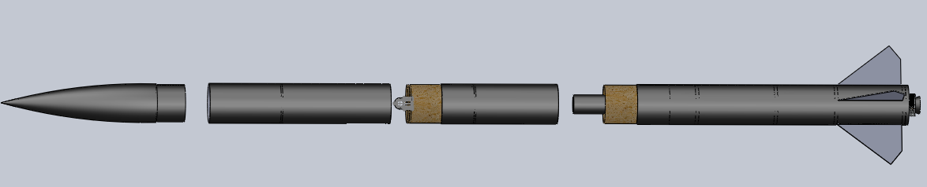
Figure 3.1: SolidWorks rendering of airframe.
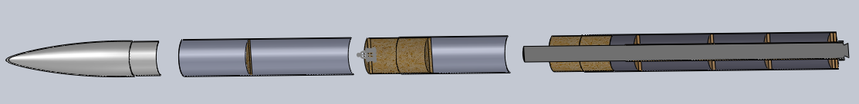
Figure 3.2: SolidWorks rendering of airframe.

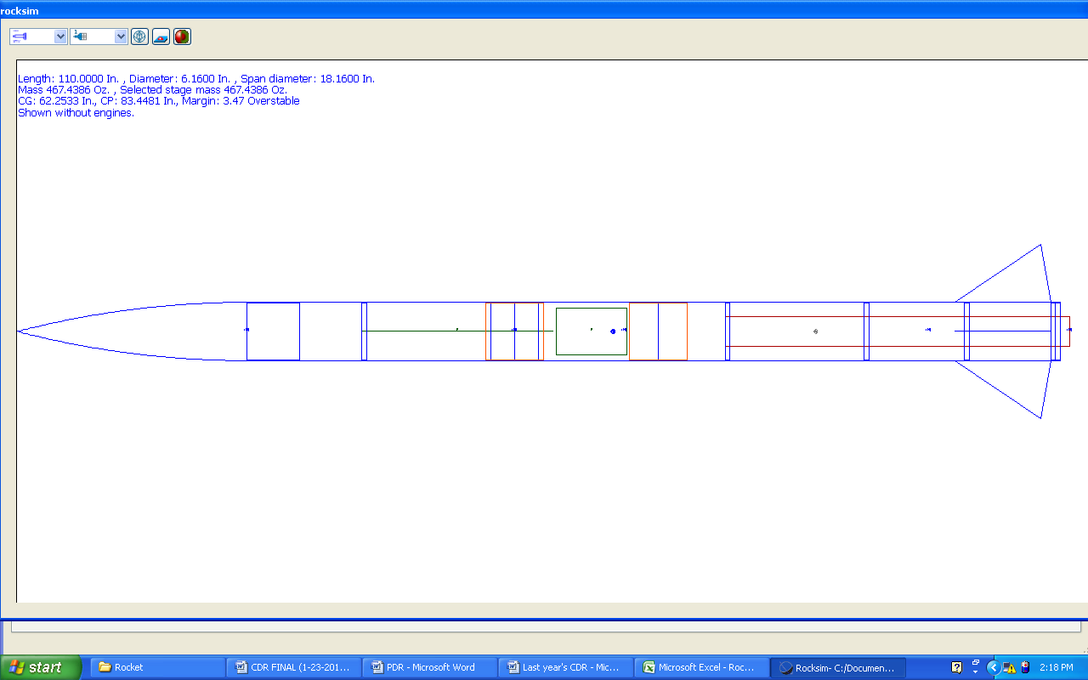Figure 3.3: RockSIM rendering of airframe.

Our simulations have placed apogee at 5,254 feet using the L-1222-SM motor from contrail rockets.
3.a.4 Demonstration of the design that meets all system level functional requirements
The Contrail Rockets 75 mm L-1222-SM rocket with a solid fuel grain and using nitrous oxidizer performed well in the RockSIM simulations. We will field test the motor in a static test when we receive it from the supplier. Then, we will conduct a full scale launch of the competition rocket with this motor system in mid March to insure that the motor will help achieve our goals.
3.a.5 Approach to workmanship as it relates to mission success
The motor is a commercial product that has been certified according to NAR requirements. It is made of steel and all components bolted together for easy assembly and breakdown after firing. We have not taken possession of the motor yet although it has been ordered. It will fit in a standard phenolic motor tube that accommodates 3 inch diameter motors.
3.a.6 Additional planned component, functional, or static testing
Now that we have finalized our airframe design and received the needed materials, we can initialize our testing. One of the major tests we will complete is a static motor test. We have had recent failures of our scale model flights, and these could have been prevented if we had tested our system on our test stand.

We plan to use pressure sensors to test the force of the separation charges in our new airframe. This will help ensure that the separation charge in the nosecone will not damage any part of the payload. We will build a scale model of our rocket and use a wind tunnel to analyze different fluid flow affects.

We will once again conduct tensile testing on our shock cords and all recovery system connections. We plan to test our payload pod’s functionality by releasing it from 200 feet and setting it to take data.
3.a.7 Status and plans of remaining manufacturing and assembly
We have currently received all of our rocket parts, but we have not begun production. We were waiting to finalize our designs. The first step will be to build the aft section. We have specifications for the aft section that will not change. Next we will build the drogue and avionics sections. We will be careful to make any adjustments to the design as needed. Finally we will complete the main section and integrate the payload system.
3.a.8 Integrity of design
We have made many changes to our fin selection as our designs have changed. The fins we finally decided upon were based on creating an ideal center of pressure and total altitude. The fins we have selected, C-07 from Public Missiles, create a stability of 2.49. We have decided that this is acceptable. Our simulations have produced an altitude of 5,254 feet.

Our fins are made of G-10 fiberglass. This material has proved to be adequately strong over the years we have used it. We will affix the fins to the motor mount and to the airframe. Also, centering rings will be located at the front and back of each fin. This can be seen in the drawings in this report. The bulkheads and centering rings will be made of ½” birch plywood. We will place five centering rings along the motor mount tube. This tube will extend 1” out of the airframe to connect the motor retainer to it. The retainer will be fastened to the last centering ring with screws. The cap will be screwed on once the motor is installed.

We will drill holes between the sections to place either permanent or shear pins into the airframe to attach it. We will place a register hole at each connection to ensure that the airframe is attached correctly. We will use an epoxy to affix our coupler tubes inside of the airframe.
3.a.9 Safety and failure analysis
Rocket analysis of failure modes including proposed and completed mitigations:

The rocket will be the most robust vehicle that we have produced. The failures experienced with previous similar rockets were:

- The airframe might slip apart before the ejection charges are fired. We are using plastic shear pins to minimize this possibility.
- The ejection charges for the drogue forced the airframe apart releasing the main parachute at apogee. The shear pins we are using should prevent this from happening.
- The parachute deployed during maximum thrust by the rocket motor, ripping the parachute from the airframe and causing total loss of rocket and payload. Our present design should not cause pressure changes that mislead the flight computers into thinking apogee had been reached prematurely.
- A fin became unglued upon landing impact. We are going to reinforce the fin to motor mount attachment with fiberglass and epoxy.
- Eyebolts may fail if the force exceeds 600 lbf. Heavier eyebolts will be chosen, if necessary, to avoid this situation.
3.b Recovery Subsystem
3.b.1 Parachute size, attachment scheme, deployment process, and test results with ejection charge and electronics
Our rocket will utilize a 44” SkyAngle drogue parachute at apogee and 120” conical parachute from Public Missiles at 800 feet. These will be deployed by 3 ounce black powder separation charges. Our avionics payload contains two PerfectFlight Mini-altimiters that will set off the charges. We are using standard tubular webbed shock cord to attach the sections of our rocket and the parachutes. The ends of the shock cord will be attached to U-bolts to bulkplates. The only exception to this is the connection of the drogue to the end of the motor that is inside the rocket. The parachutes will be attached by a D-ring to a know in the shock cord. We intend to use shear pins in our main section to guarantee that the main chute will not be deployed early. This was a problem last year and led to almost loosing the rocket as it drifted down slowly to Earth.

Our RockSim simulations have given an estimated descent rate of 66 ft/s under drogue and 20 ft/s under main. We have tested an older rocket of the same materials we are using this year to conclude that a 3 ounce charge is adequate to separate the rocket. We will test our competition rocket for this year when the building stages have been completed. We have also previously tested the altimeters in the laboratory and in flight and they have been successful in every test.

We will recover our rocket body once it has touched down using the Walston Retrieval System with CA MODA 3750 MVS-HF Rocket Transmitter, TRX-3S 3-Channel Receiver, and Folding 3-element Antenna.
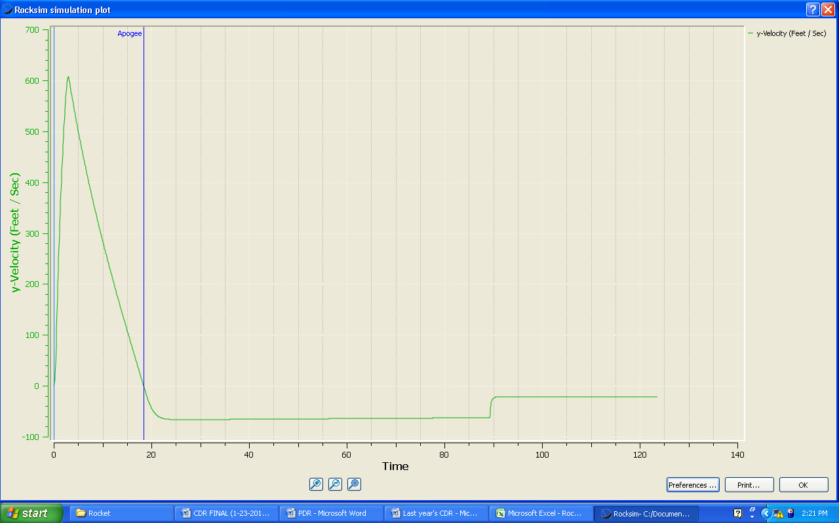
Figure 3.4: Flight predictions for acceleration in the y direction.
3.b.2 Safety and failure analysis
Concern | Analysis
Early deployment of drogue | This is a problem that we have faced in the past. The parachutes were deployed at maximum thrust and the airframe failed catastrophically. We will combat this problem by testing our altimeters regularly.
Deployment of main at apogee | This is also a problem that we have faced in the past. There is no safety risk, but an early main deployment will cause the rocket to drift out of it’s intended landing zone. We will ensure this will not happen by adding shear pins to the connection of the avionics section with the main section.
No deployment of drogue | This is failure that concerns us the most. A rocket that has gone ballistic is obviously a major safety concern. We have never had a problem with this, but we continue to test our altimeters and we always use at least two altimeters with back-up charges.
No deployment of main | This is a concern for the completion of our competition goals. Although this failure would not be as dangerous, it still produces an unsafe situation to bystanders. It would also lead to a much more forceful impact of the rocket with the ground. This could cause damage to the airframe and the flight computers.
Separation of parachute from rocket | We are aware that it is a possibility that the parachute could become separated from the shock cord or the the shock cord could become separated from the rocket. We ensure they will stay together by using shock cord with a high factor of safety and knots that are intended to be used for high powered rocketry. Our connection hardware is also tested to a high factor of safety. We have tested all of these components with a tensile testing machine in the engineering laboratory.
Rocket damage during descent | A common problem we have found is airframe “zippering” and airframe damage due to mid-air collisions of the airframe. We mitigate the mid-air collisions by measuring our shock cord so that each piece of the airframe will hang down a different amount from the parachutes. We tackle the “zippering” affect by placing our charges on the side of the parachute this is pushed out of the airframe.
3.c Mission Performance Predictions
3.c.1 Mission performance criteria.
Performance of the launch vehicle in flight will be subject to these criteria:
- Vehicle reaches velocity for stable flight before leaving launch guide.
- Vehicle maintains stable flight throughout.
- Vehicle does not "weathercock" unreasonably.
- Vehicle reaches apogee at target altitude of 5,280 feet.
- Vehicle descends at 66 feet/sec under drogue.
- Vehicle descends at 20 feet/sec under main.

3.c.2 Flight profile simulations, altitude predictions with real vehicle data, component weights, and actual motor thrust curve
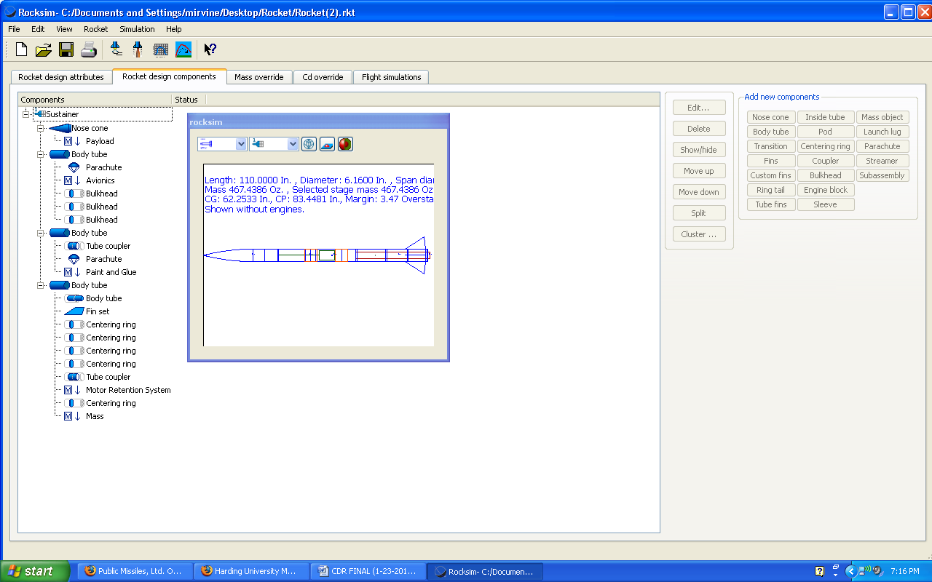
Figure 3.5: Parts list of all components for the airframe. The final mass is 467.4 ounces.

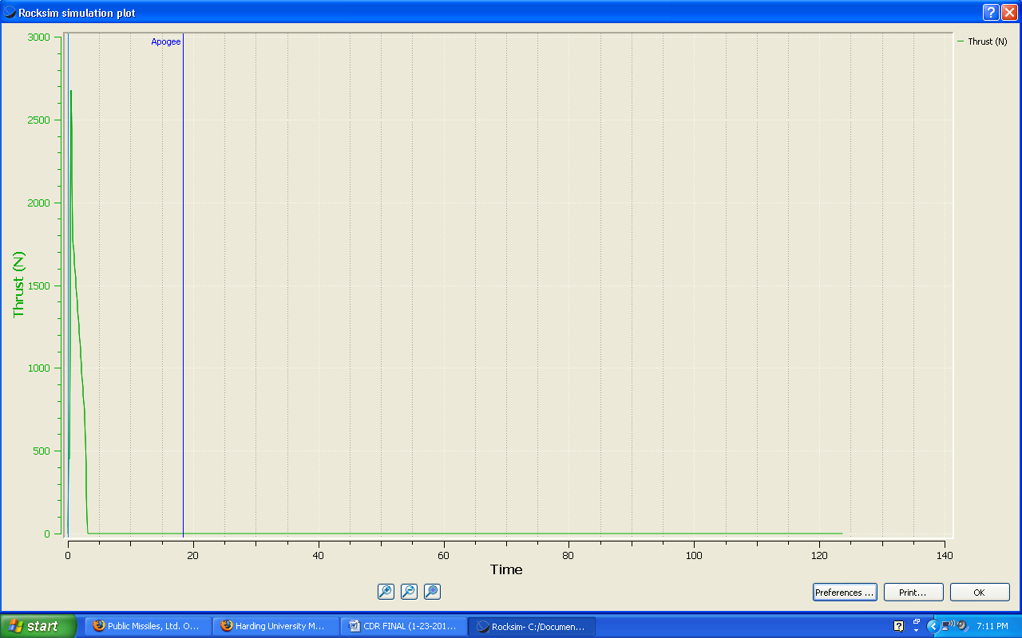
Figure 3.6: Thrust curve for simulated flight with final design specifications.
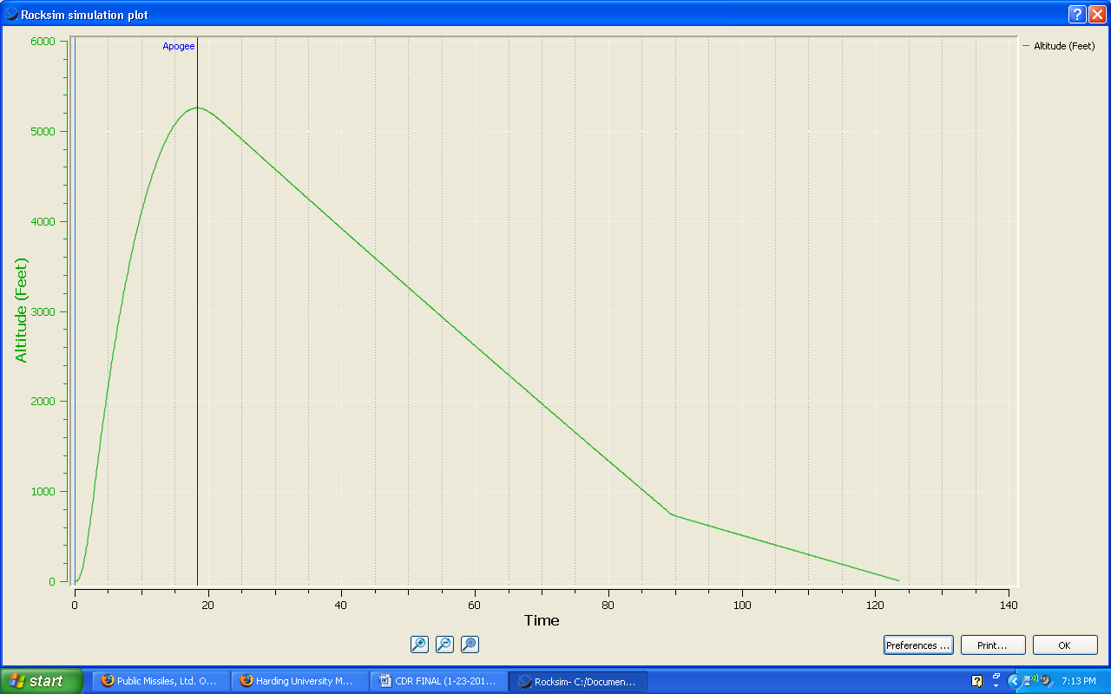
Figure 3.7: Flight simulation plot for the altitude of the airframe during flight. The simulated apogee is 5,254 feet.

3.c.3 Validity of analysis, drag assessment, and scale modeling results
We have found our RockSIM simulations to be valid in the past, and we expect them to be valid once again. We still plan to conduct wind tunnel testing on a scale model of our rocket.
3.c.4 Stability margin and the actual CP and CG relationship and locations
The stability margin is 2.49. The CP is located at 68.2 inches from the front of the rocket and the CG is located at 83.4 inches from the front of the rocket.
3.d Payload Integration
3.d.1 Integration plan
The structure of the payload is shown in figure 3.8. The centerpiece of the payload is a large aluminum plate. One 2.5 inch long piece of bar stock extends down from the plate. Three spring-loaded legs made of ABS plastic will be attached by hinges to the plate and connected by springs to the bar underneath the plate. Four aluminum rods will be attached to the top of the plate. They will be spaced evenly around the outside edge. The batteries and camera will sit on the plate. The microcontroller will be placed above this plate. The sensors and the GPS will sit on the top platform.
The payload will be positioned in the rocket as seen in figure 3.9. The bottom plate will be positioned inside the airframe near the connection of the main airframe with the nosecone. At 2,500 feet of elevation, the altimeter included in the payload will set off directional charges located at the end of the nosecone. The nosecone will hang from the main rocket by a shock cord. Without the nosecone, the payload will be free to fall from the rocket. This will cause the payload parachute to deploy. The aluminum plate will protect the electronics in the payload from the blast. The rods on the top of the plate will prevent the electronics from bashing into the bulk plate further aft in the rocket.
The four legs will open upon separation from the rocket. These will be tucked inside the nosecone as shown in figure 3.9. A small hole will be drilled out of the side of the main airframe to allow the sensors to take accurate data. Also, the light sensitive sensors will be directed out of this hole.

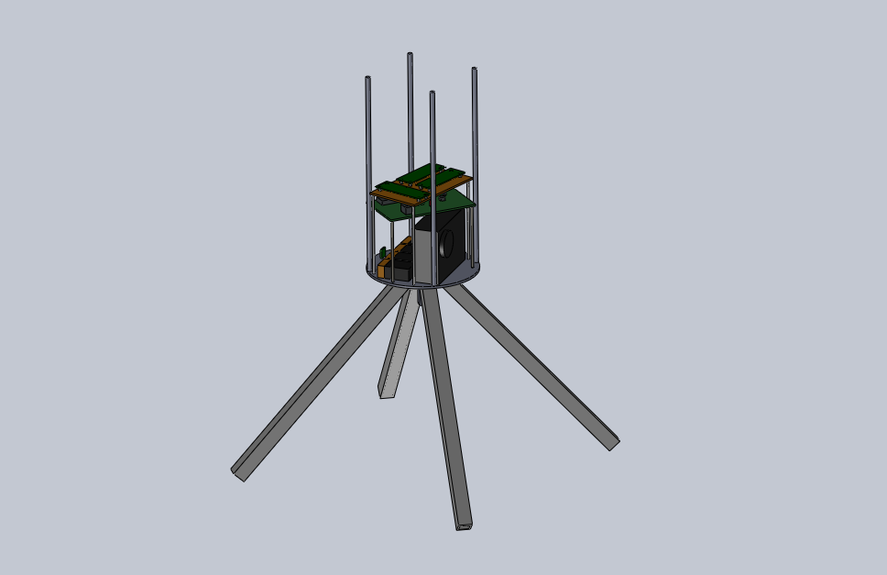
Figure 3.8: SolidWorks drawing of payload.

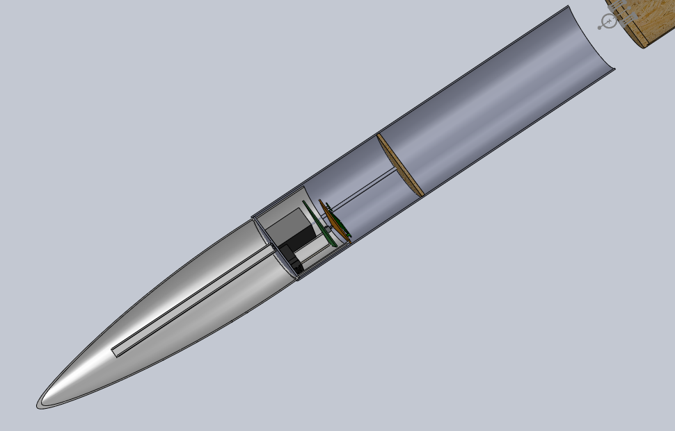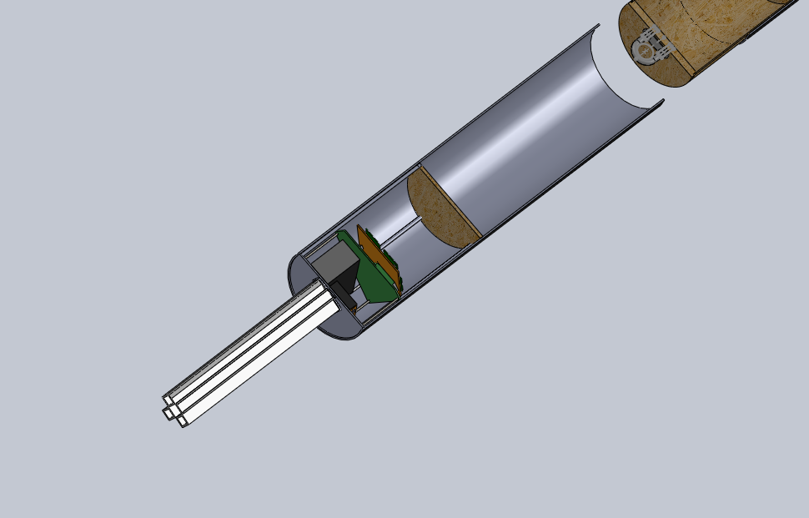
Figure 3.9: Payload integrated into the airframe.
3.d.2 Installation and removal, interface dimensions, and precision fit
The metal rods on top of the aluminum plate in the rocket will press firmly against the bulk plate. The plastic legs will fit tightly in the nosecone. The distance from the front of the body tube to the bulk plate is 11 inches. The payload will need to be built shorter than this. The legs of the payload can be molded too long and then can be shaved until the correct fit is achieved. Installation of the payload will then be a simple matter of placing the payload in the rocket because it will fit tightly on its own.

The dimensions for the computer are 3 in. x 5 in. This means that the computer will be able to fit in the 6 in. diameter rocket with about 0.1 in. to 0.2 in. to spare. The 12 V batteries and all of the other electronics are relatively small and will fit in their positions easily.
3.d.3 Compatibility of elements
Since the payload body is made of standard high powered rocket parts used in virtually all rocket construction, all the materials are compatible. All the components of the electronic devices are on standard acrylic circuit boards and will be bolted into the payload. The plastic legs will be attached to the payload with aluminum hinges. The top platform which contains the sensor circuits will be made of fiberglass. No gases, liquids or chemicals are part of the experiment.
3.d.4 Simplicity of integration procedure
One concern for the payload is that it will make the rocket top heavy. The weight of the payload has been accounted for in the calculations, but these are only approximations and the actual weight might be higher. It might be necessary to find ways to lighten the payload.

Tests will need to be done to make sure that the separation charges will not harm any of the payload components by measuring the force of a test blast.

The nosecone might impede the payload as it falls out of the rocket after the separation charges have ignited. The shock cord connecting the nosecone to the rocket will need to be made long enough to keep the nosecone sufficiently removed from the front of the rocket after it is blown off.
3.e Launch Concerns and Operation Procedures
3.e.1 Draft of final assembly and launch procedures
Two days prior to departure:
Weigh nitrous tanks
Charge all batteries - extras included.
Organize and check tool box for supplies.
Check supply list to make sure everything is accounted for

One day prior to departure:
Clear departure time with all team members
Send Vice President for Academic Affairs an Excuse Request for students
Set everything required for the trip in one location and go through the supply list one-by-one to make sure everything needed is accounted for.

Departure Day
Pick up van; load rocket and supplies; load students; travel to Huntsville
Friday, 16 April 2010 – Launch Day -1
Prep rocket motor
Assemble and install payload

Launch Day
Bring rocket and all necessary supplies to launch site.
Perform final preparations and notify range officer when ready for launch
Launch team carries rocket, launch stand, ignition system and nitrous system and ignition cable to launch area 500 ft from observation site
Launch Manager performs final check on instruments and rocket
Launch commences
Recovery
Return to hotel

3.e.2 Recovery preparation
All charges will be prepared and integrated by the avionics manager. He will be responsible for insuring the flight location transmitter is mounted securely in the Science Payload Coupler and is powered properly at launch. Another team member will use the folded antenna to track the rocket vehicle until it lands. These two plus another Recovery Division member will recover the rocket from the field, photograph it, inspect it briefly and bring it back to the launch site where the data from the science experiment and flight recorders can be downloaded onto a laptop computer.
3.e.3 Motor preparation
See appendix section 7.b for the motor preparation manual.
3.e.4 Igniter installation
See appendix section 7.b for the igniter installation instructions.

3.e.5 Setup on launcher
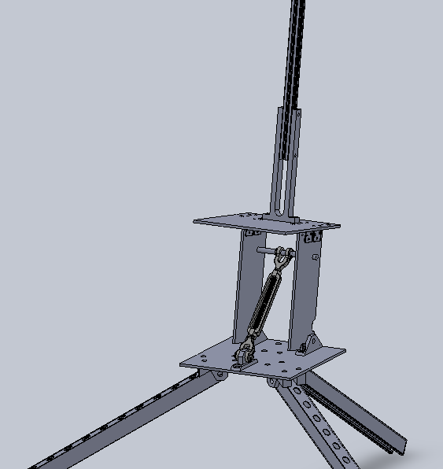
Figure 3.10: An image of our launch stand in SolidWorks.

Figure 3.10 shows the rocket launch platform designed for launching high powered rockets. The launch rail can be loosened by removing a clevis pin so that it can be lowered horizontal for loading the rocket onto the rail. The system can be adjusted to provide a launch angle from near horizontal to vertical. A flash arrestor protects the ground below from fire starts. The rail is a one inch square aluminum T-Slotted Framing Rail, McMaster-Carr part number 47065T101. It has a 1/4th inch slot for the launch rails.
3.e.6 Troubleshooting
The launch attempt on October 30th helped the team to get a feel for the types of problems that occur during a launch as several problems came up. The team was able to work through the problems, though, and fix them as they came up. The full scale launch in mid March will help to identify any other trouble points. The launch will give the launch team the experience necessary to carry out a successful launch in a professional, timely manner. It will also help to fill the procedure manual for the competition launch.
3.e.7 Post flight inspection
The post flight inspection is a valuable part of the launch process. Photographs will be taken of the landing site and the landed rocket. Cursory inspection at the landing site will reveal whether or not the rocket fared well upon landing. Once the rocket is brought back to the launch area, a more detailed inspection will be conducted and the data from the experiment and the flight computers will be downloaded to a laptop computer.
3.f Safety and Environment (Vehicle)
3.f.1 Safety officer for the team
Edmond Wilson, Team Official, is the Safety Officer for the Harding Flying Bison 2011 USLI Rocket Team. He holds a NAR Level 2 Certification.
3.f.2 Preliminary failure modes and mitigations
3.f.2.a Airframe:
- Airframe fails to hold motor in place causing motor to tear through the airframe.
- We will reinforce the hardware which holds the motor casing thrust ring in place.
- Motor falls backwards out of motor housing tube during flight. We will use a commercial motor retainer to prevent this failure.
- The airframe fails to separate when separation charges ignite. We will sand down the junctions properly to ensure that they are loose enough to separate but still tight enough to hold together during flight.
- Fins become separated or tear through the airframe upon hard landing. We will reinforce attachment of the fins to the airframe and to the motor housing tube with Kevlar or nylon using epoxy adhesive.
- Shock cords separate when deployed. We have perform tensile strength measurements on the shock cords to pick the minimum size cord that will be strong enough and increase the size to twice tensile strength specified.
- The primary flight computer malfunctions. We have a second flight computer that will provide the same functions and sensors to the rocket as the primary, which we can use in the case of any damage or malfunction to the primary computer.
3.f.2.b Payload:
- Batteries will fail during launch. We will install brand new fresh batteries as part of the rocket preparation. Each electronic system will have its own battery supply. We also will bring extra charged batteries to the launch site.
- Circuit boards and batteries break off their mounting boards and devices at launch. We will pay special attention to making these mounting boards and battery holders as strong and solid as possible.
- Cables detach during pre-launch or launch. We will reinforce the connections with tape to prevent separation.

3.f.2.c Launch Operations:
- Five hundred foot cable connecting rocket ignition box at the rocket launch pad with the operator controls fails. We can test the connectivity prior to launch and correct any problems.
- Battery failure in operator control box. We will bring a back-up battery and make sure the original battery is charged and tested just before launch.
- Nitrous oxide cylinder too warm or two cold producing pressures below 600 psi or greater than 900 psi. We will keep the nitrous in a thermal container that can be filled with either ice water or hot water to adjust the temperature. In April one usually needs to cool the nitrous cylinder.
3.f.3 Personnel hazard research
- Exposure of skin and eyes to epoxy resins – Exposure of hands to epoxy adhesive materials will be minimized by the use of protective eyewear and gloves.
- Exposure of skin and eyes to fiberglass fibers and Kevlar™ fibers – Exposure of hands to fiberglass fibers and Kevlar™ fibers will be minimized by the use of protective eyewear and gloves.
- Exposure of eyes and lungs to acrylic spray paint – All painting will be done with doors to shop opened and vent fan on. Protective eyewear and a mask covering nostrils and mouth will be worn.
- Trauma to body from improper use of hand tools – Proper use of hand tools will be explained as needed for each process undertaken.
- Trauma to body from improper use of metalworking machines – All team members will wear protective eyewear, and instruction on preventing injury to the body during work periods will be conducted repeatedly for each phase of the work.
- Proper use of the nitrous oxide cylinders, regulators, and controls will be explained before use. The Safety Officer will supervise launch activities dealing with nitrous. Pressures between 600 and 900 psi will be maintained on the nitrous storage cylinders by surrounding them in thermal jackets in which ice water or warm water can be added as needed. Personnel will be at least 500 feet from the launch area while loading the nitrous into the rocket motor. This will prevent anyone from receiving frostbite from an uncontrolled leak. All operations for the nitrous will be done by electrical valves except for initial turn-on of the main cylinder valve during initial launch setup and after launch. A dump valve is part of the equipment in case of failure to launch. Once a rocket is launched or aborted, the main cylinder valve will have to be manually turned off.
3.f.4 Environmental concerns
- Our procedure, if followed correctly, should pose little or no harm whatsoever to the environment.
- The blast plate will protect surrounding vegetation from the blast of ignition.
- Following every launch, the site will be cleaned up of any trash or debris from launch or recovery area.
- Only two or three people will be sent to recover the rocket, and they will be respectful of the surrounding environment.
- The oxidizing agent, nitrous oxide, will leak into the atmosphere in very small amounts, where it will quickly disperse. The amount is much too small to cause any amount of harm to the environment.
- The fuel, hydroxyterminated polybutadiene, is essentially only rubber. The spent fuel grain will be disposed of in a landfill, where it will eventually degrade into water and carbon dioxide.
4. Payload Criteria
4.a Testing and Design of Payload Experiment
4.a.1 Review of the design at a system level
The payload will consist of the pressure sensor, the temperature sensor, solar radiance/UV sensor, humidity sensor, the micro-controller, and the GPS. It will all be placed in a circuit board. The other circuit board will contain the camera’s circuitry. Note that the UV sensor faces toward the outside.
- Temperature Subsystem -- the temperature transducer will be measured with a National Semiconductor LM50CIM3 transducer. This temperature transducer reads directly in Celsius degrees (10 mV/⁰C). The nonlinearity is less than 0.8 ⁰C over its temperature range of -40 ⁰C to +125 ⁰C. The accuracy at 25 ⁰C is ±2% of reading. It operates with any single polarity power supply delivering between 4.5 and 10 V. Its current drain is less than 130 mA.
- Pressure Subsystem -- the pressure transducer is an ASDX015A24R Honeywell device with a pressure measuring range of 0 to 15 psi and a burst pressure of 30 psi. It is powered by voltages in the range of 4.75 Vdc to 5.25 Vdc and has a current consumption of 6 mA. It will operate in the temperature range of -20 ⁰C to 105 ⁰C. It survives 10 gram vibrations from 20 Hz to 2000 Hz and can survive a 100 g shock for 11 ms. Its lifetime is 1 million cycles minimum. The device is accurate to ±2% H full scale.

- Solar Irradiance and UV Radiation Subsystem—an Osi-optoelectronics UDT-455 UV/LN component which is a photodiode-amplifier hybrid. While operating, the temperature range is 0 - +70°C. A spectral range can produce a response of 200nm to 1000nm. Supplied voltage usually is of ±15 V, hence the quiescent current supplied will be of 0.9 mA.
- Relative Humidity Subsystem— a Honeywell HIH 4000-Series component will be used. With current operating at 200 microA and calibrated at 5Vdc, ±2% RH(Relative Humidity), 0-100% RH non-condensing, 25 °C is possible. The sensor is a laser trimmed thermo set polymer capacitive sensing element with on-chip integrated signal conditioning. The sensing element's multilayer construction provides excellent resistance to application hazards such as wetting, dust, dirt, oils, and common environmental chemicals.

- Camera Subsystem -- a Vivitar Vivicam V7022 Graphite with 7.1 MP resolution and 4x digital zoom will be used. The flight computers will initialize the data capture at apogee and a pull switch will initialize the camera during descent. A 555 timer with a one-shot trigger will take the pictures after the payload has touched the ground.

- MicroController-- an EL™ is a high performance, C/C++ programmable controller based on a 40/80MHz 16-bit CPU. With a precision 2.5V reference, a sigma-delta 24-bit ADC (LTC2448, 5 KHz, 0-1.25V) offers 8 channel differential or 16 channel single- ended input channels. A 16-bit parallel ADC (AD7655, 0-5V) supports ultra high-speed (1 MHz conversion rate) analog signal acquisition. A 16-bit DAC(LTC2600) provides 8 analog output voltages (0-5V). The EL supports up to 2 GB mass storage Compact Flash cards with Windows compatible FAT file system support, allowing user easily transfer large amounts of data to or from a PC.

Analysis results
The analysis has not yet started because we are still waiting on merchandise to arrive to complete the circuitry. When the sensors and the rest of the electronic parts have arrived, analysis will be done individually. As we are mounting each part to the circuit board, analysis will be done to verify the system works properly.
Test results
Testing has not started due to reasons previously stated; we are still waiting on the merchandise to arrive.
Integrity of design
Analysis of the design prior to construction ensures that the system as a whole will result positively. Individual tests will be performed, and as stated previously, when the system is being mounted to the circuit board, tests will guarantee the system works with the rest of the subsystems.
4.a.2 Demonstration of the design meeting all system level functional requirements
Our design does meet all of the requirements asked for in our payload design. It contains the following:
- a pressure sensor that will record pressure at constant intervals over the rocket trajectory
- a temperature sensor to be used to record temperature as a function of altitude
- a relative humidity sensor to accurately measure the humidity in the air during the flight.
- a UV radiation sensor to detect ultraviolet radiation from 200 to 1100 nm. The spectral response of the silicon photodiode detector is a good match to the spectrum of solar irradiance.
- a camera that will take two pictures during descent and three after landing.
4.a.3 Approach to workmanship as it relates to mission success
We will use mainly common parts that have stood the test of time. We will use some components of ABS plastic. These parts will be tested to make sure that they are acceptable. We will use fasteners with a very high factor of safety.
4.a.4 Planned component testing, functional testing, or static testing
Before construction of the payload takes place, we will connect all of our sensors to our microcontroller to ensure that they all work. We will also test our other payload components as we receive them. Once we are confident they are in working order, we will test the system as a whole in the vacuum to make sure the system is working properly. Our last step of testing before our full scale flight test will be to allow our payload to descend from 150 feet to ensure everything works properly. We will begin this testing in early February.
4.a.5 Status and plans of remaining manufacturing and assembly
We are still waiting on hardware to arrive and will have the entire board built in time for the FRR. The circuit board is an EL™, and once the rest of the parts arrive they will be wired, and after tests and results, the payload will be complete.
4.a.6 Integration plan
Refer to section 3.d.1.
4.a.7 Precision of instrumentation and repeatability of measurement
Refer to 4.a.1 for each system. Each instrument can be used more than one time and once the memory is recovered from the microprocessor the payload will be ready to fly.
4.a.8 Safety and failure analysis
Payload analysis of failure modes including proposed and completed mitigations:
- The payload fits completely inside the rocket airframe. The payload has flown successfully previously with no failure. We will pay attention to the robustness of all electrical connections and be sure to use fresh batteries. The power does not come on until the drogue parachute is deployed.
- The payload will be flown on the test flight of the competition rocket to further test for failure.
- The science payload coupler will undergo a series of tests to evaluate its structural integrity.
4.b Payload Concept Features and Definition
4.b.1 Creativity and Originality
Due to our choice of selecting the SMD suggested payload, our payload is not particularly creative in its objectives. We feel our creativity is seen in the design of our actual payload pod. We chose to build a system that would release spring loaded legs after separation from the payload. We are also including a trigger on two feet of the payload to alert the system when it has landed.
4.b.2 Uniqueness or significance
Although finding data such as temperature in our atmosphere is not overly significant, finding the temperatures of the atmosphere for distant planets could prove to be very useful. This payload construction leads our design team to understand and build a system that could possibly be used in another atmosphere.

4.b.3 Suitable level of challenge
This is a very appropriate project for college science and engineering students. CAD design, metal and electronic fabrication, tensile strength machines, presses and wind tunnels will be used. There will be lots of testing and calibration completed. Finally, reports such as this one will all help to enhance the education of participants with real-world hands-on activities.

4.c Science Value
4.c.1 Payload objective
The payload division must complete the following objectives:
-Test and calibrate a pressure sensor that will record pressure at constant
intervals over the rocket trajectory
-Test and calibrate a temperature sensor to be used to record temperature as a
function of altitude
-Test and calibrate the relative humidity sensor to accurately measure the
humidity in the air during the flight.
-Test and calibrate the UV radiation sensor to detect ultraviolet radiation from
200 to 1100 nm. The spectral response of the silicon photodiode detector is a good match to the spectrum of solar irradiance.
-The camera must take two pictures during descent and three after landing.

4.c.2 Payload success criteria

Success will be measured by

The ability of the payload to implement all of the sensors in a way that efficiently
gathers the data.

The sensors excel by gathering the proper data and storing it in the computer
memory. That is, measurements taken at least every five seconds during descent
and every 60 seconds after landing ending within 10 minutes after landing.

4.c.3 Experimental logic, approach, and methods
We will conduct our atmospheric research by using simple sensors integrated onto a payload pod. We will build a circuit to take data at a certain rate and combine that data with the data from our altimeters to study the changes of the dependant variable with the change in altitude.

4.c.4 Variables and controls
Variables will be the height at which the measurements are taking place.
The measurements will be ambient pressure, humidity, temperature, and sunlight
intensity. We are expecting all of the sensors’ operating ranges of values.

4.c.5 Relevance and error analysis
The data that will be collected will help show how the sun’s energy heats the air.
Data collected will be compared to that anticipated when possible. Accuracy can then
be estimated. Error analysis will be made during laboratory testing once the payload is
complete and testing begun

4.c.6 Preliminary experiment process procedures
The payload section remains inactive until the rocket reaches apogee and the
drogue parachute is released. At this time, the payload receives a signal to begin to take data. When the rocket has descended to 2500 feet, the nose cone is separated from the rocket and the payload is released which causes the spring loaded legs to be pushed to their final position. As the payload is separated, a timer is begun to send a signal to the camera to take pictures during the second half of descent. Upon landing, a trigger will be activated for the camera to take three more pictures and for data to be recorded at a new rate. The payload is located using the GPS system and data is retrieved through a USB port.
4.d Safety and Environment (Payload)
4.d.1 Safety officer for your team
Edmond Wilson, Team Official, is the Safety Officer for the Harding Flying Bison 2011 USLI Rocket Team. He holds a NAR Level 2 Certification.
4.d.2 Update of the preliminary analysis of the failure modes of the proposed design of the rocket and payload integration and launch operations, including proposed and completed mitigations

Rocket analysis of failure modes including proposed and completed mitigations:

- A fin became unglued upon landing impact. We are going to reinforce the fin to motor mount attachment with fiberglass and epoxy.
- The airframe might slip apart before the ejection charges are fired. We are using plastic shear pins to minimize this possibility.
- The rocket might be lost upon landing. We have designed a radio transmitter recovery system that will allow us to track and find the rocket upon landing.
- Payload analysis of failure modes including proposed and completed mitigations
- The payload fits completely inside a coupler on the rocket airframe. The payload has flown successfully previously with no failure. We will pay attention to the robustness of all electrical connections and be sure to use fresh batteries. The power does not come on until a g-switch initiates data recording upon lift-off.
- The payload will be flown on the test flight of the competition rocket to further test for failure.
- The science payload coupler is undergoing a series of tests to evaluate its structural integrity.
- Launch operations analysis of failure modes including proposed and completed mitigations
- Loss of some oxidizer after filling and before countdown and launch. This was due to a misunderstanding on our part of how far the launch team had to be from the rocket. We now are ready to deploy the rocket from a distance of over 318 feet and we know how to maintain the oxidizer tank full until the launch command is given.
- The nitrous oxidizer supply tank became too warm raising the pressure of nitrous to unacceptable levels for filling the rocket. We now have a procedure and hardware for maintaining the temperature of the nitrous supply tank to within a safe range.
- The fuel ignition system failed because the voltage through the electric matches was too low. We now add a 12 volt battery in series with the ignition unit to proved ample voltage and current for ignition.
4.d.3 Update of the listing of personnel hazards, and data demonstrating that safety hazards have been researched (such as material safety data sheets, operator’s manuals, NAR regulations), and that hazard mitigations
have been addressed and mitigated
Personnel hazards include:

- Injury to eyes or hands while machining payload or airframe parts. All will wear protective eyewear and instruction on preventing injury to the body during work periods will be conducted repeatedly for each phase of the work.

- Proper use of hand tools will be explained as needed for each process undertaken.

- Instruction on how to solder properly will be given when electrical circuits are being assembled.

- No chemicals are used in constructing or operating the payload. Only epoxy resin and spray acrylic paint is used in construction of airframe and payload. Protective gloves and face masks will be worn when working with these chemicals. The workplace will have the vent fan turned on to keep the fume levels to a minimum.

- All NAR regulations, MSDS safety sheets and tool and instrument manuals are being collected together in one central location for workers to access during the construction and testing phase.
4.d.4 Environmental concerns
Discuss any environmental concerns:

- All payload work will be done in the laboratory under air-conditioning. No chemicals will be used. Other than brief smoke from the soldering process, there are no chemical hazards. Burns from inadvertently touch heated portion of soldering iron are virtually unknown and the small areas affected can easily be treated with burn ointment and band-aids.

- No electrical voltages high enough to cause shock are encountered with the equipment used.

- Our plan would pose no damage to the environment. We will use a flash arrestor on the bottom of our launch stand to protect the surrounding grass and weeds from catching on fire.

- A clean-up of the site after each launch will be conducted to remove trash and debris from the launch and recovery area.

- Only two to three people will enter the field to recover the rocket and they will be respectful of the crops in the launch field.

- The oxidizer is nitrous oxide. A small amount of this will be leaked to the atmosphere where it will be quickly dispersed. The amount will not contribute in any measurable way to the greenhouse effect.

  - Activity Plan
5.a Budget Plan

We have currently allocated $100 dollars for educational outreach. This is enough to cover the minor materials we use for our outreach opportunities. We settled on this number because we have found in the past that outreach opportunities have required very few expenses. We often use recycled materials to do any activities and our own rocket supplies for educational demonstrations..
5.b Educational Engagement Timeline
Launch Day: 10-30-10 (Completed) We held a launch day for new members and anyone else who was interested in coming to see the team fly our 2010 competition rocket and a smaller scale rocket.
Cub Scouts: 11-29-10 (Completed) We met with a Cub Scout troop here in Searcy to give an interactive presentation on our rocket project. We gave an informative presentation on what we did as a rocket team.We let the children see some of the rockets from previous competitions and taught them some basics of rocketry through a series of hands-on activities.
Spring 2011 (Not completed) We will follow up on our contact with the Cub Scout troop by helping the children build their own model rockets and launch them.
Westside Elementary: Ongoing (Completed) We have sent a representative to teach a lesson on rocketry and we will have another visit with the school to launch rockets that the students have built.
Elementary School in Little Rock: Spring 2011 (Not Completed) We have made a contact with an elementary school teacher in Little Rock who is interested in having our team help with educational rocketry lessons. We are currently following up and finding out more about this opportunity.
Other educational engagement opportunities:
We have planned to work with the Roosevelt Institution on campus to teach nearby students at rural schools about science. We are still in the planning stages of this project and plan to begin execution in the spring.
  - Conclusion

We have now completed the final designs for the airframe and the payload. We have confidence in our designs and will begin final testing shortly. In the weeks to come we plan to complete our tests of strength, fluid flow, and payload functionality. We intend to construct our payload as the first stage of construction. During this process we might find that we have overlooked something, and the airframe is strongly dependant on the payload pod. This would result in possible changes to the airframe. We hope to fly our competition rocket before the FRR report is completed.

  - Appendix
7.a Camera Wiring Diagrams
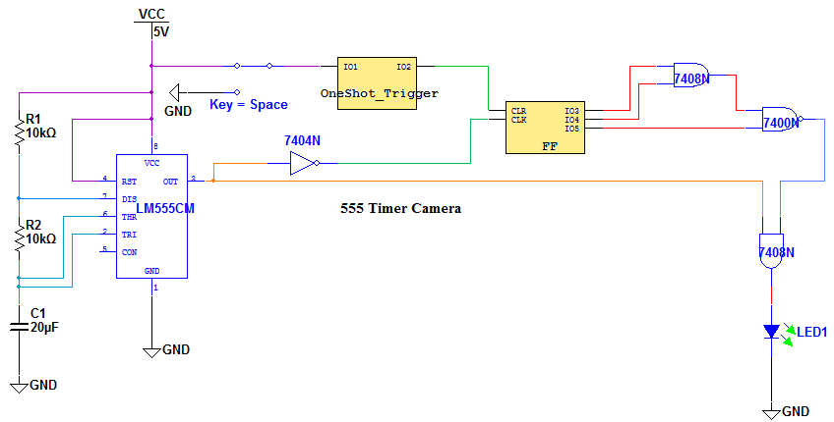
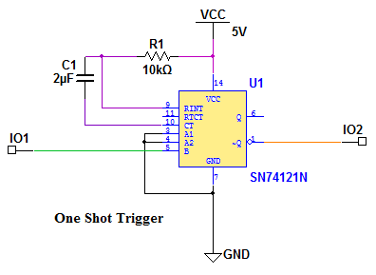

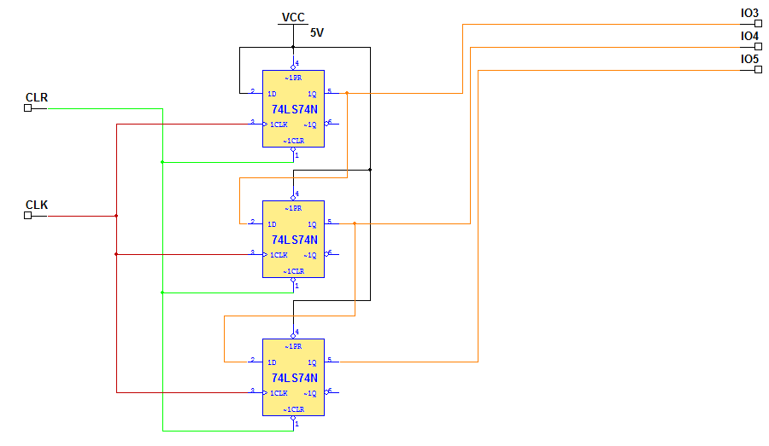

7.b Motor Preparation

Contrail Rockets
75mm Hybrid Rocket Motor Reload
Instruction Manual
Congratulations on your purchase of a Contrail Rockets 75mm Hybrid Reload. The supplied motor reload has been designed to operate in Contrail Rockets Hardware only. Before you begin assembly of this reload, please read through this manual and familiarize yourself with the steps. If you have any questions please contact Contrail Rockets.
Included With this Reload Package is:
Quantity | Item Name
1 | Fuel Grain
5 | Press-Lock Injectors (User Selected At Time of Purchase)
2 | Igniters (24 Volt Resistor Type Igniter)
2 | Nylon Fill Lines (User Selected At Time of Purchase)
1 | Nylon Crossover Line (Short version of item above)
1 | 1/8 Inch Vent Line (Clear)
2 | O-Rings (Size 230)
1 | Instruction Manual

Not Included With this Reload Package is:
Synthetic Type Grease (Mobile 1 Synthetic or Similar Recommended)
Pyrodex Pellets (Muzzle Loading Pellets, Size 50/50 Recommended)
Deep Wall Socket Set
7/16 Inch Socket for 1/8, and 3/16 Inch Injectors
1/2 Inch Socket for 1/4 Inch Injectors
Allen Wrench (1/4 Inch Allen Wrench for 75mm Motors)
Good Pair of Cutters (Recommended: Radio Shack Coax Cable Cutters)
Roll of Electrical Tape
Cleaning Supplies for Post Flight Cleanup

Motor Assembly Instructions

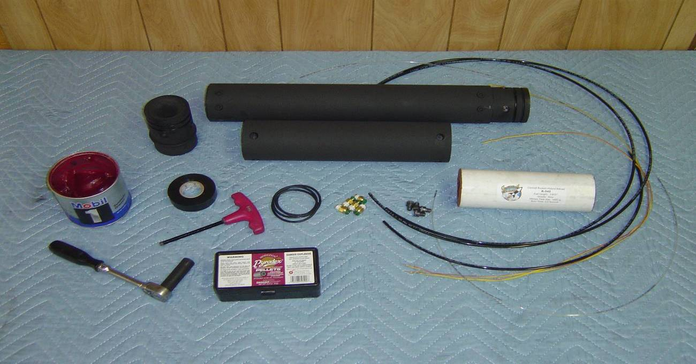
Step 1: Ensure that your motor hardware is clean and free from grease, oils, dirt and debris. Wipe the motor components with soap and water, to cut any residual grease from previous firings. Make sure you have all required tools and parts for motor assembly.

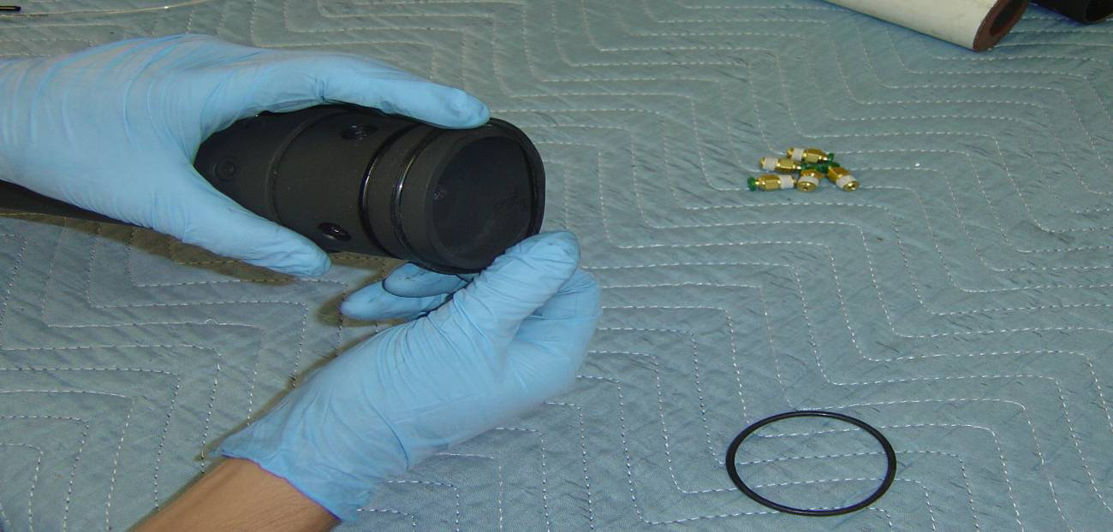
Step 2: Begin by installing all O-Rings onto Nozzle and Injector Baffle. All O-rings are Dash Number 230. O-Rings should be free from any cracks, burns or damage.

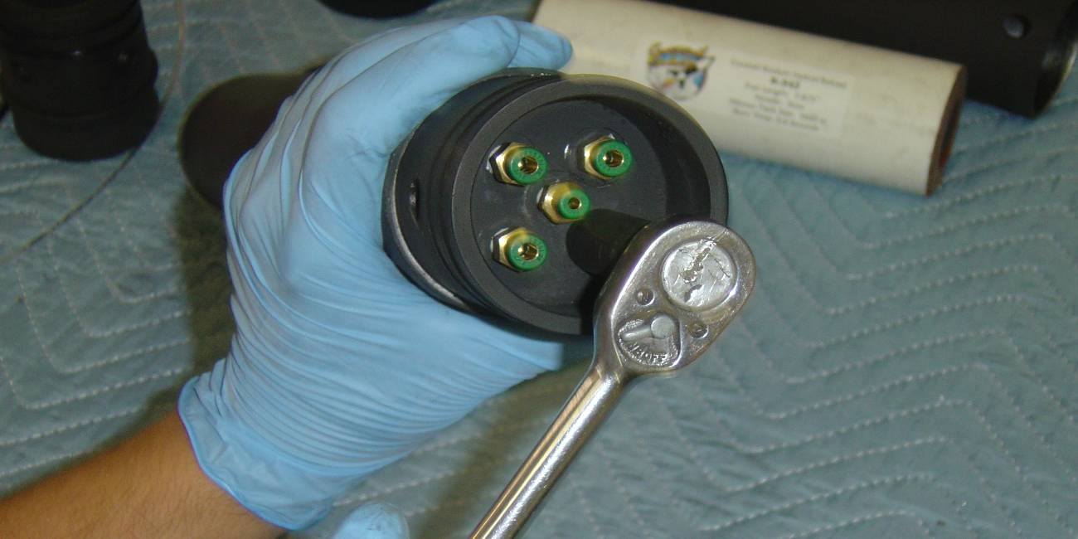
Step 3: Insert Press Lock Fittings into the Injector Face. A 1/8 Inch Fitting will always go in the center port. 1/8 inch Fittings are used for Slow Motors, 3/16 for Medium Motors and 1/4 Inch for Fast Motors. The Fittings should be tightened ½ turn past tight.

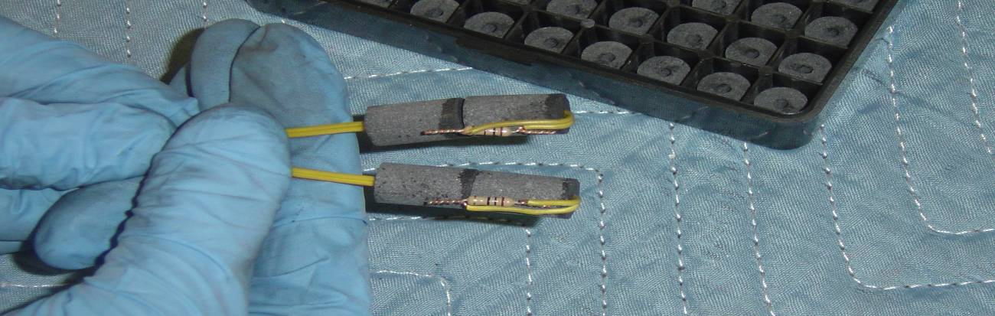
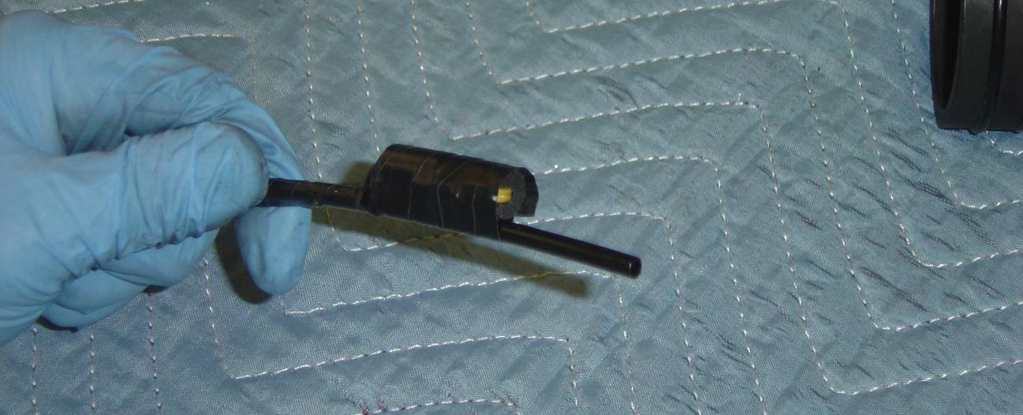
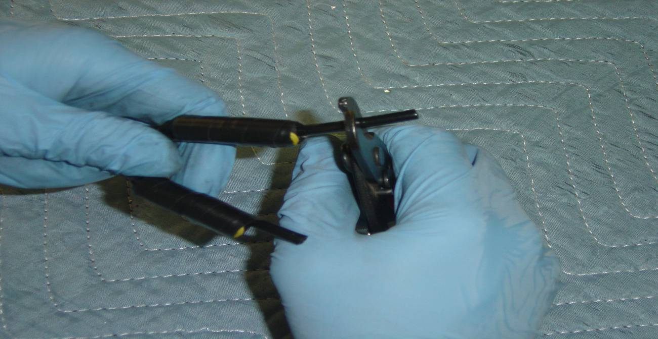
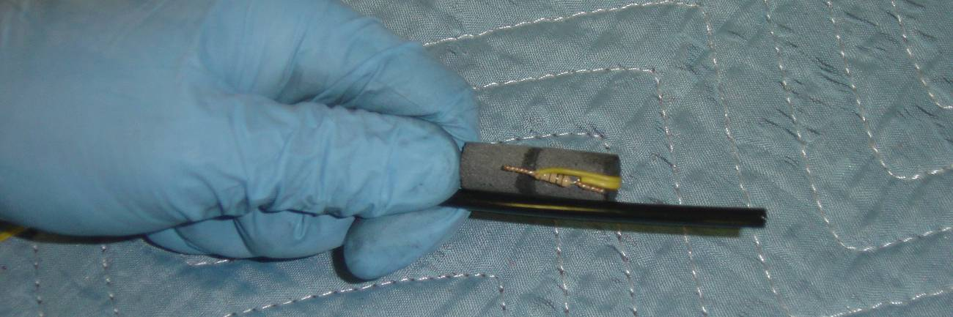
Step 4: (Previous 4 Photo’s): Verify that you have the correct size and number of Pyrodex Pellets for your reload and then slide the igniter wire through the center hole of the pellet. Bend the resistor to the side of the powder pellet as shown. For 75mm motors we recommend (2) 50 Caliber/50 Grain Pyrodex Pellets. Ensure that you have placed the Resistor 90 Degrees away from the Nylon Line. This ensures proper ignition of the Pyrodex Pellet before the line bursts. The Pyrodex Pellets should be taped together and it is recommended that 2 wraps of Electrical tape should be sufficient over the entire igniter assembly to ensure ignition. Too Much Electrical Tape can be a bad thing and cause the pellets to burn to fast. You only need enough tape to hold them to the line. Prior to Moving onto the next step, ensure the lines are cut square and at a length of approximately ¾ of an inch from the top of the Pyrodex Pellets.

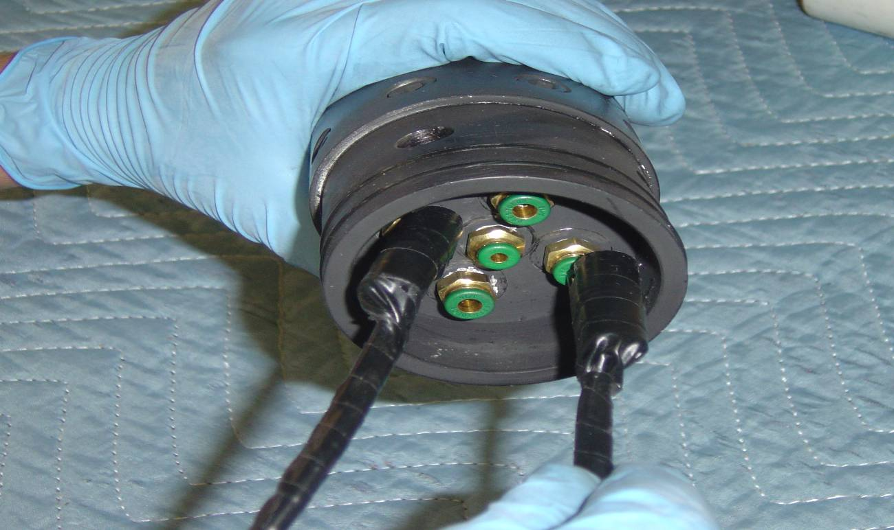
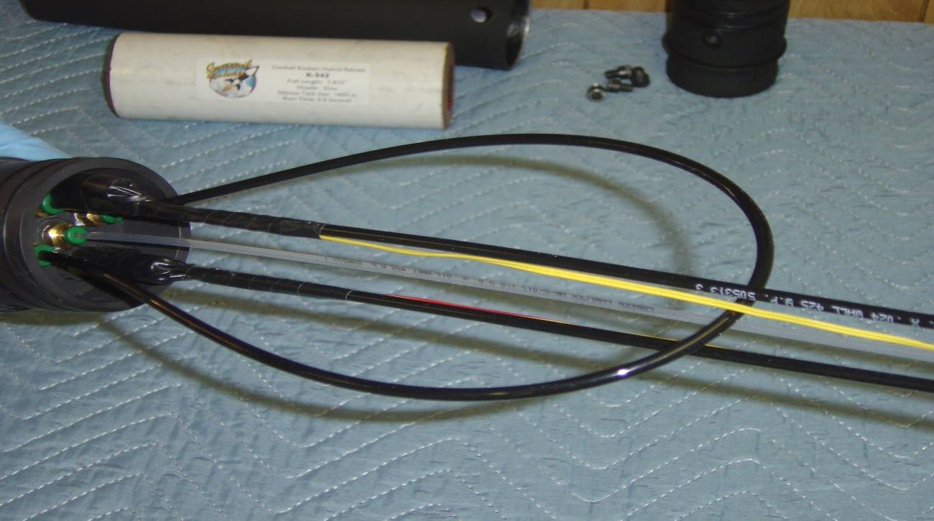

Step 5: Insert the Fill lines w/ Pyrodex Pellets attached into the injector baffle on opposite sides. Ensure that the nylon lines go all the way into the press locks and go past the O-Ring Seal. You will feel it go past the O-ring and seat at the bottom of the fitting. You will now insert the clear vent line into the center fitting, and the short crossover line into the last 2 fittings. Ensure that all the lines are secure in the fittings prior to moving on.

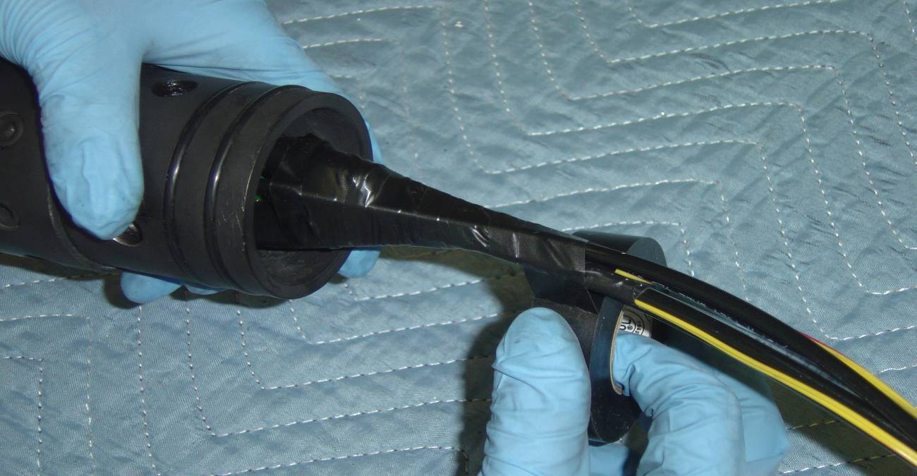

Step 6: Using your roll of electrical tape, start taping around all 5 nylon lines. This will slightly pull the lines towards the center of the motor, and ensure the heat of the Pyrodex Pellets at ignition is kept near the lines to ensure a positive ignition. You will only need a single layer of tape over the line set to hold them together.

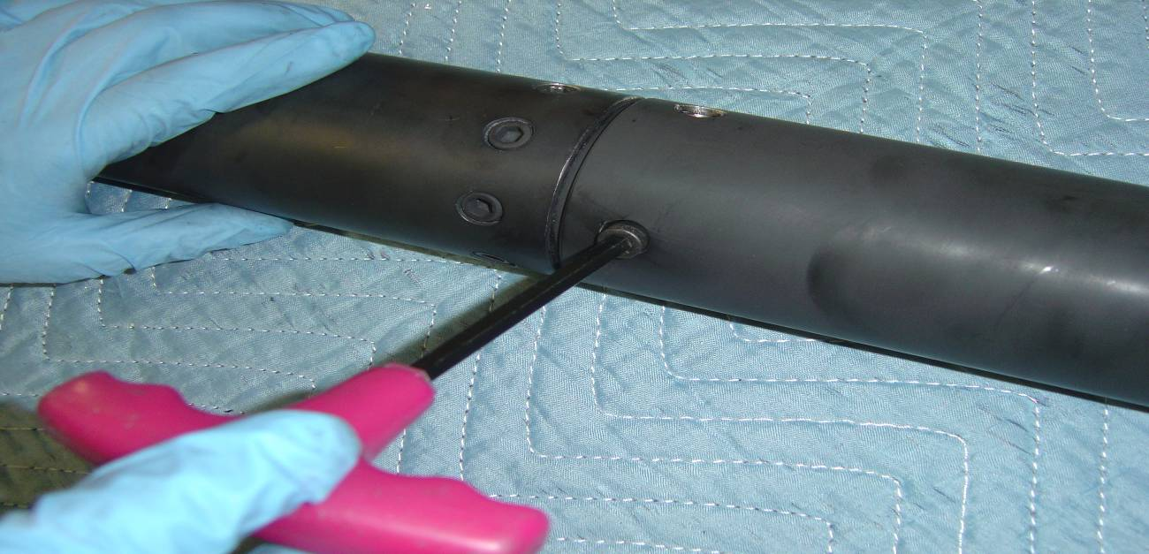
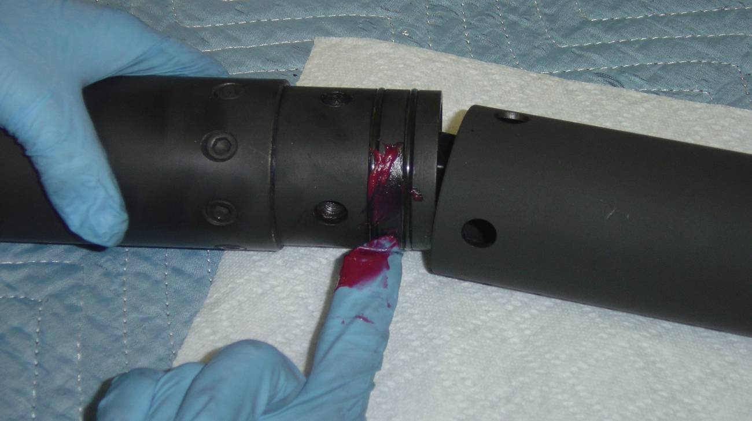

Step 7: Grease the Injector Baffle O-rings and slide the nitrous tank section of the motor onto the combustion chamber and insert the retention bolts. The bolts will require a ¼ inch hex head wrench.

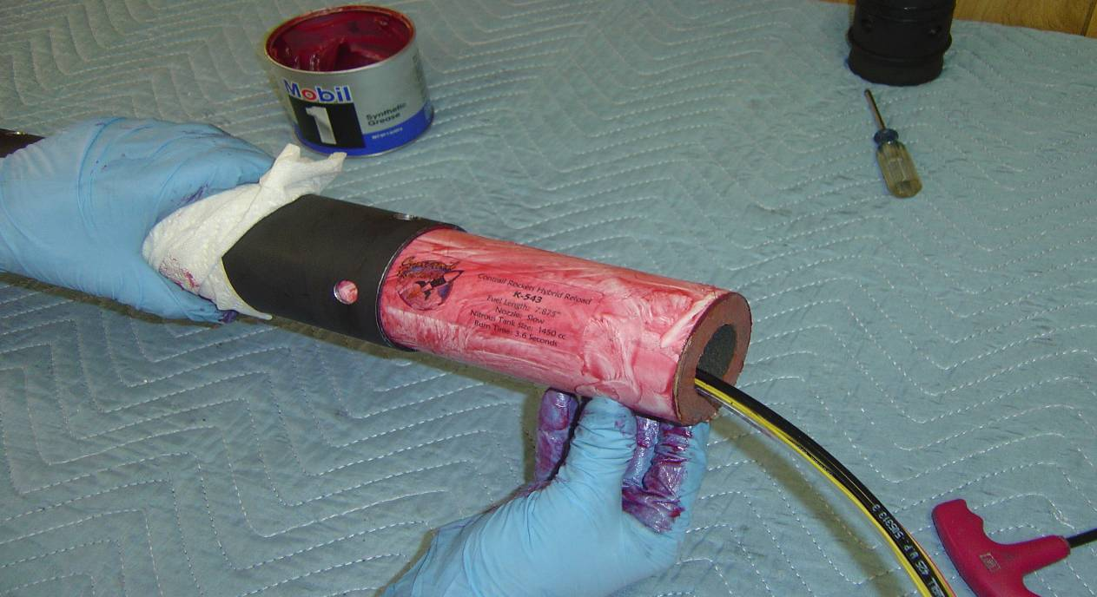
Step 8: Grease the included fuel grain with a synthetic type grease (Mobile 1 or similar) and slide the fuel grain into the combustion chamber. Ensure that the fill lines, vent line and igniter wires are all drawn through the core of the grain. A thin coating of grease is all that is required.

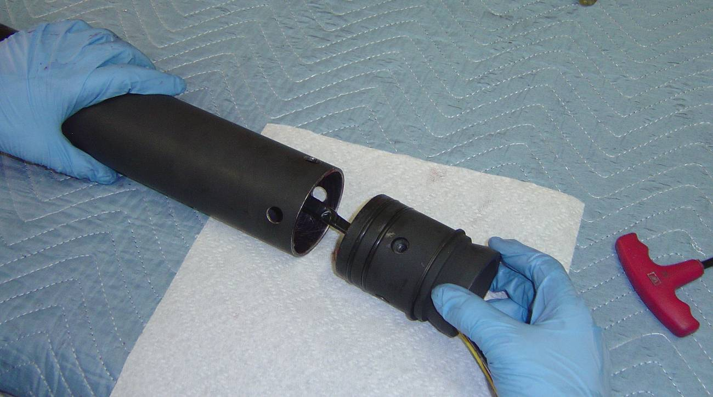
Step 9: Grease the Nozzle O-rings and slide the nozzle into the combustion chamber. If you will be using a retaining ring on the nozzle, be sure to put this onto the nozzle prior to bolting it into the combustion chamber.

